***Indianization of Oscar Wilde’s short story “The Selfish Giant”***

**Output of the Project :**

**The Ghost and the Children**

There was a haunted house in very old village. The house was about 150 years old. It was built by an old Sahib named Hamilton.  Its windows were in broken condition, gutters were hanging off it. Different types of bushes covered the crack in the wall. But still there were few old oil paintings on the wall. It seemed to one that the somber portraits were staring at him behind the layer of dust. Hesitant light streamed in through the cracked windows, casting eerie shadows on the walls. In that house, there inhabited a Ghost for 30 years. When the Ghost was alive, he once came in the same house for spending the Puja vacation. But there he died in the stove burst. From then the Ghost of that man remained in the house. After that death, people came to that house for picnic. But the Ghost was very selfish. Besides human beings, he even did not like any other Ghost to come to his haunt. But he did not able to detain them to come in his house. Then he one day played a trick and showed his horrendous figure to the people presented in the house. From that time no man dare to come to his house compound even in daylight except the children.

There was a beautiful garden in that house. Every afternoon, returning from school, the children used to go and play in that garden. It was a large lovely garden, with soft green grass. Here and there over the grass stood beautiful flowers like stars, and there were twelve Magnolia trees that in the spring-time broke out into delicate white blossoms, and in the autumn bore rich fruit. The birds sat on the trees and sang so sweetly that the children used to stop their games in order to listen to them. "How happy we are here!" they cried to each other.

One day the Ghost came back. He had been to visit his friend the Sitaram Senapati, another renowned ghost and had stayed with him for seven years. After the seven years were over he had said all that he had to say, for his conversation was limited, and he determined to return to his own castle. When he arrived he saw the children playing in the garden.

"What are you doing here?" he cried in a very gruff voice, and the children ran away.

"My own garden is my own garden," said the Ghost; "anyone can understand that, and I will allow nobody to play in it but myself." So he built a high wall all round it, and put up a notice-board.

***" TRESPASSERS***

***WILL BE***

***PROSECUTED "***

Now the children had nowhere to play except the dusty and stony road. They did not like to play there. The wandered around the high wall of the garden and sighed in futility. Then the Spring came, and all over the country. Only in the garden of the Selfish Ghost it was still winter. The birds did not care to sing in it as there were no children, and the trees forgot to blossom. The only people who were pleased were the Thunder and the Storm. "Spring has forgotten this garden," they cried, "so we will live here all the year round." The Thunder filled the atmosphere with lightening, and the Storm painted all the trees with dust. Then they invited the North Wind to stay with them, and he came. He was wrapped in furs, and he roared all day about the garden, and blew the chimney-pots down. "This is a delightful spot," he said, "we must ask the Hail on a visit." So the Hail came. Every day for three hours he rattled on the roof of the castle till he broke most of the slates, and then he ran round and round the garden as fast as he could go. He was dressed in grey, and his breath was like ice.

It made the Ghost very much disappointed and he used to say while looking outside through the window, “I cannot understand why the Spring is so late in coming, I hope there will be a change in the weather." But his expectation was wrong. The Spring never came.

One morning the Ghost was awaked from his sleep by a sweet tone. It filled his mind with joy because it was nothing but the sound of the birds’ chirping. It was so long since he had heard a bird sing in his garden that it seemed to him to be the most beautiful music in the world. He also discovered through his window that the Storm, Thunder all had gone and again the trees had yield beautiful flowers. Then the Ghost was heard to remark, "I believe the Spring has come at last" and he hurriedly came out. He noticed that through a little hole in the wall the children had crept in, and they were sitting in the branches of the trees. In every tree, he could see there was a little child. And the trees were so glad to have the children back again that they had covered themselves with blossoms, and were waving their arms gently above the children's heads. The birds were flying about and twittering with delight. It was a lovely scene, only in one corner it was still winter. It was the farthest corner of the garden, and in it was standing a little boy. He was so small that he could not reach up to the branches of the tree, and he was wandering all round it, crying bitterly. The poor tree was still quite covered with frost and snow, and the North Wind was blowing and roaring above it. "Climb up! little boy," said the Tree, and it bent its branches down as low as it could; but the boy was too tiny to reach.

Seeing it, the Ghost realized everything and said, “How selfish I have been! Now I know why the Spring would not come here. I will put that poor little boy on the top of the tree, and then I will knock down the wall, and my garden shall be the children's playground forever." He was really very sorry for what he had done so far.

But when the children saw the Ghost, they were so frightened that they all ran away, and the garden became winter again. Only the little boy did not run, for his eyes were so full of tears that he did not see the Ghost coming. And the Ghost stole up behind him and took him gently in his hand, and put him up into the tree. And the tree broke at once into blossom, and the birds came and sang on it, and the little boy stretched out his two arms and flung them round the Ghost's neck, and kissed him. And the other children, when they saw that the Ghost was not wicked any longer, came running back, and with them came the Spring. "It is your garden now, little children," said the Ghost, and he took a great axe and knocked down the wall. Afterwards the children played in the garden all day long, and in the evening they came to the Ghost to bid him good-bye.

All day long they played, and in the evening they came to the Ghost to bid him good-bye. But that boy whom the Ghost put into the tree, did not come again in the garden. Everyday when rest of the children came to play, the Ghost asked them about that little boy; but they replied that they did not know him. It made him feel very sad. The Ghost was very kind to all the children, yet he longed for his first little friend, and often spoke of him. "How I would like to see him!" he used to say.

Years went over, and the Ghost grew very old and feeble. He could not play about any more, so he sat in a huge armchair, and watched the children at their games, and admired his garden. "I have many beautiful flowers," he said; "but the children are the most beautiful flowers of all."

One winter morning he looked out of his window as he was dressing. He did not hate the Winter now, for he knew that it was merely the Spring asleep, and that the flowers were resting. Suddenly he rubbed his eyes in wonder, and looked - It certainly was a marvelous sight. In the farthest corner of the garden, beneath a tree it stood that little boy he had loved.

Downstairs ran the Ghost in great joy, and out into the garden. He hastened across the grass, and came near to the child. And when he came quite close his face grew red with anger, saw a mark like ‘Trisul’ printed on his forehead with liquid dust and he said, "What is that on your forehead and who has dared to make your face dirty?" cried the Ghost; "tell me, that I may take my big sword and slay him."

"Nay!" answered the child; "but this are the mark of God’s Love."

"Who are you?" said the Ghost, and a strange awe fell on him, and he knelt before the little child.

And the child smiled on the Ghost, and said to him, "I’m Krishna, you let me play once in your garden, to-day you shall come with me to my garden, which is Paradise" and he vanished in the air.

Later when the children ran in that afternoon, they found the Ghost lying dead under the tree, all covered with white blossoms.

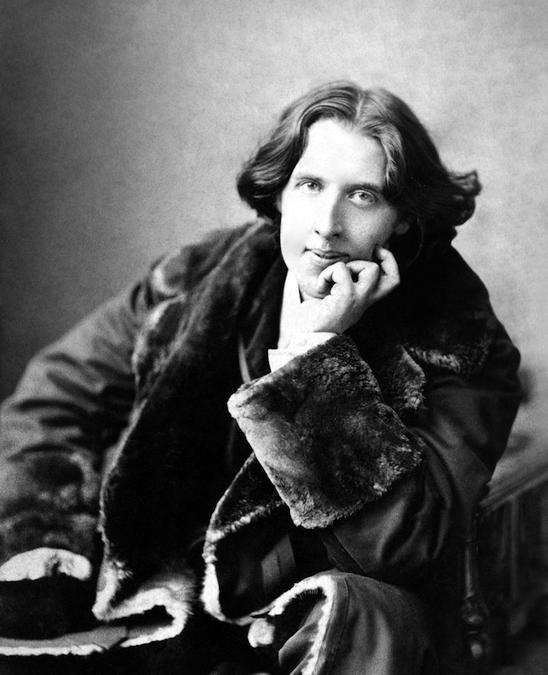**IMAGE RESOURCES:-**

